User Manual
for
Course Management System

Introduction: It’s a dynamic course management system including student , teacher and dynamic course management.

Here,

Default Email and Passwords:
Admin- admin@cms.com (admin12345)
Student Staff – staff_student@cms.com (staff12345)
Course Committee – course_committee@cms.com (committee12345)
Teacher – (teacher12345)
Student – (iit12345)

Please change the password after your first login!
Log In page:

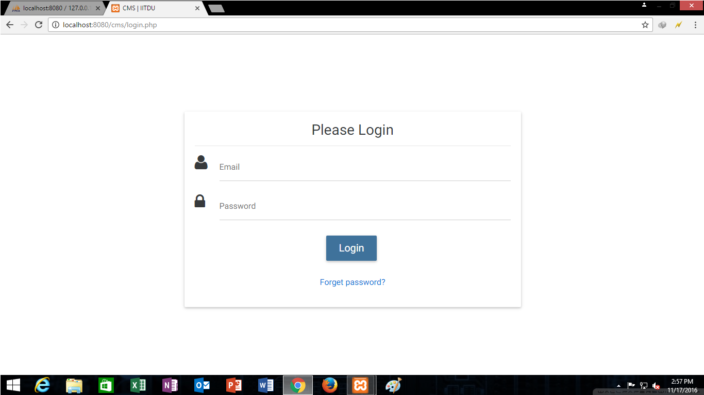

Enter specific user name and password for system admin, course committee, teacher, student staff and students and get into the system.

Forgot Password page:

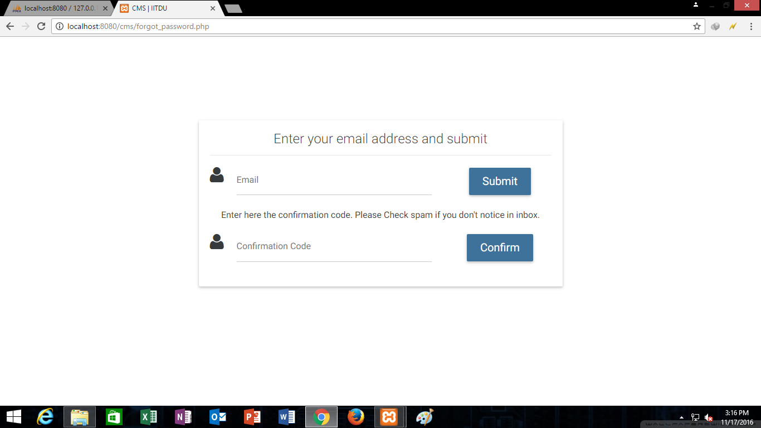

If email or password is wrong, then the forgot password page comes in.

System Admin (Home page):

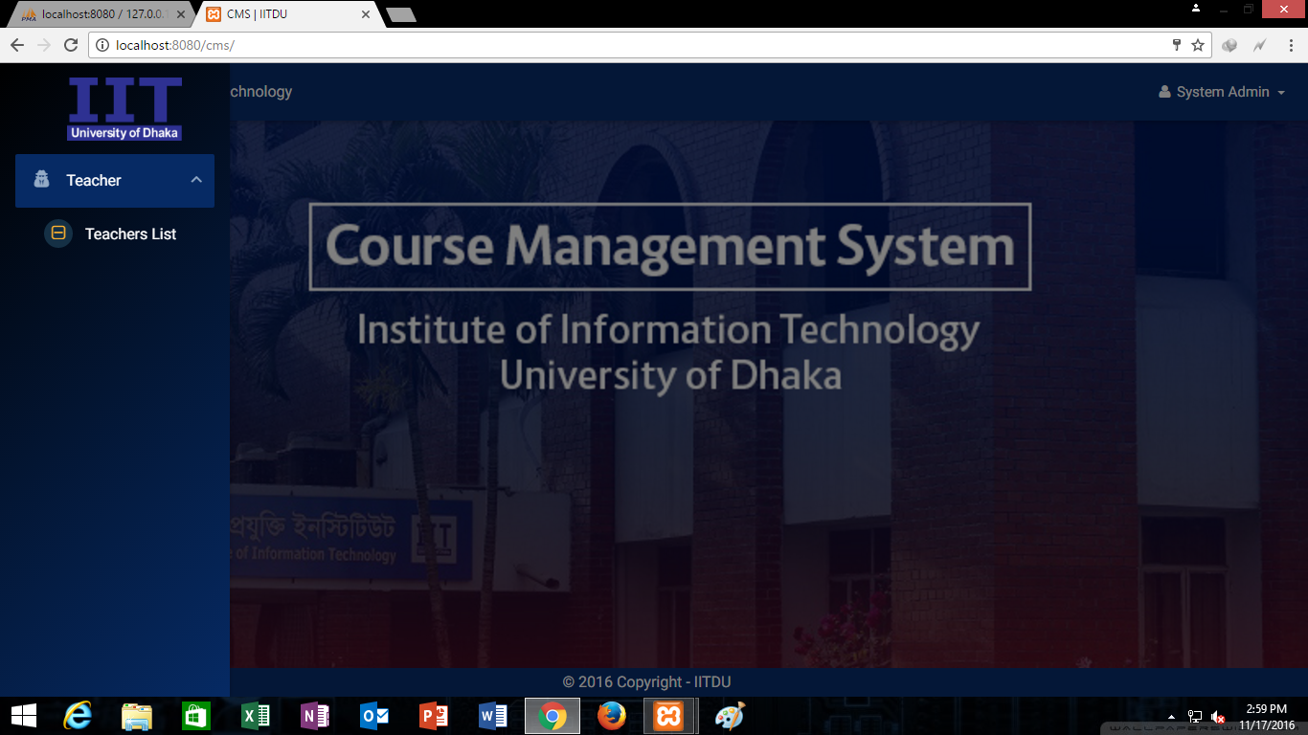

In system admin home page the admin can see the teachers list.

System Admin (Teacher list page):

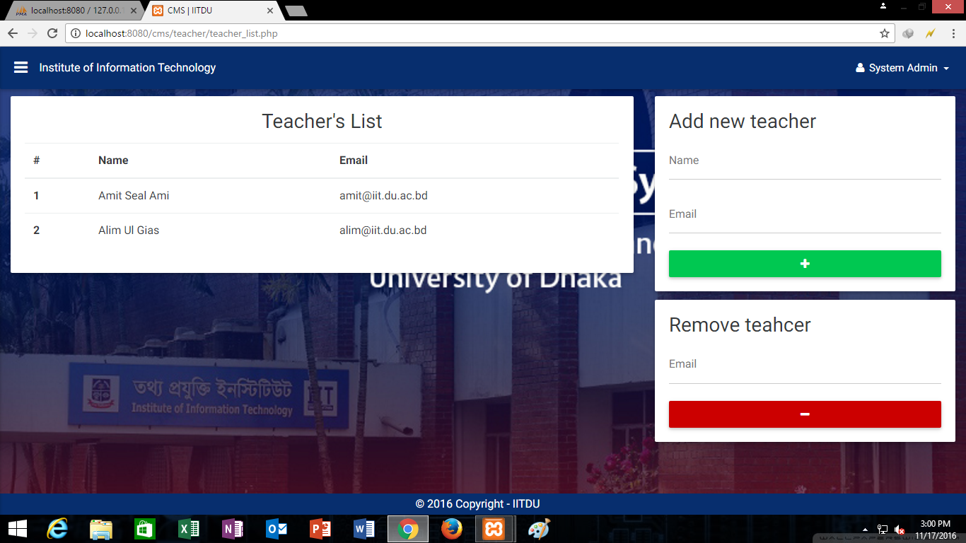

In teachers list page the system admin can add a new teacher or remove teacher.

Student Staff (Home page):

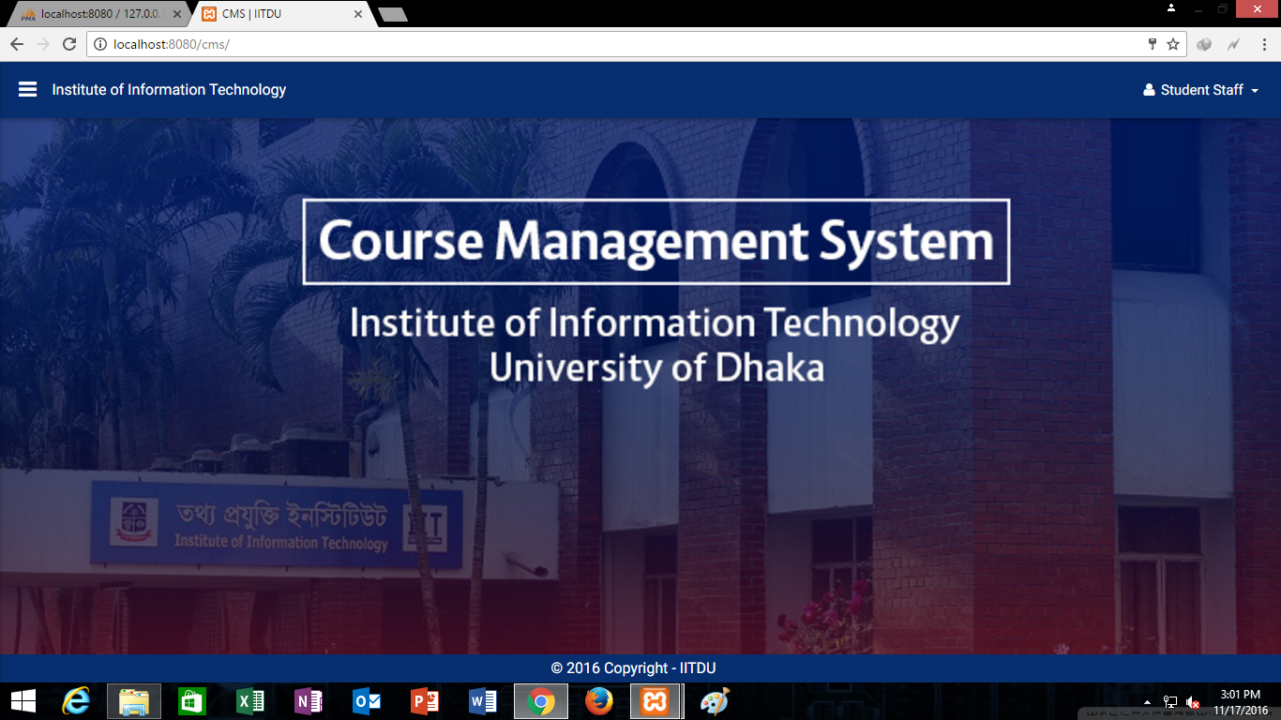

Student Staff (Student list page):

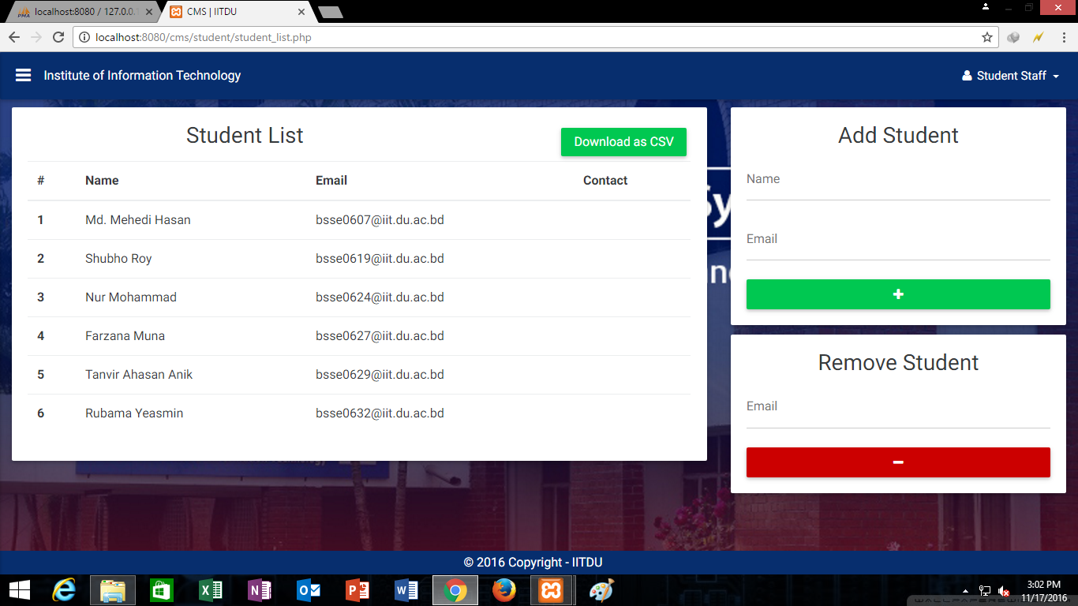

In this page the student staff can add a new student or remove student.

Course Committee (Home page):

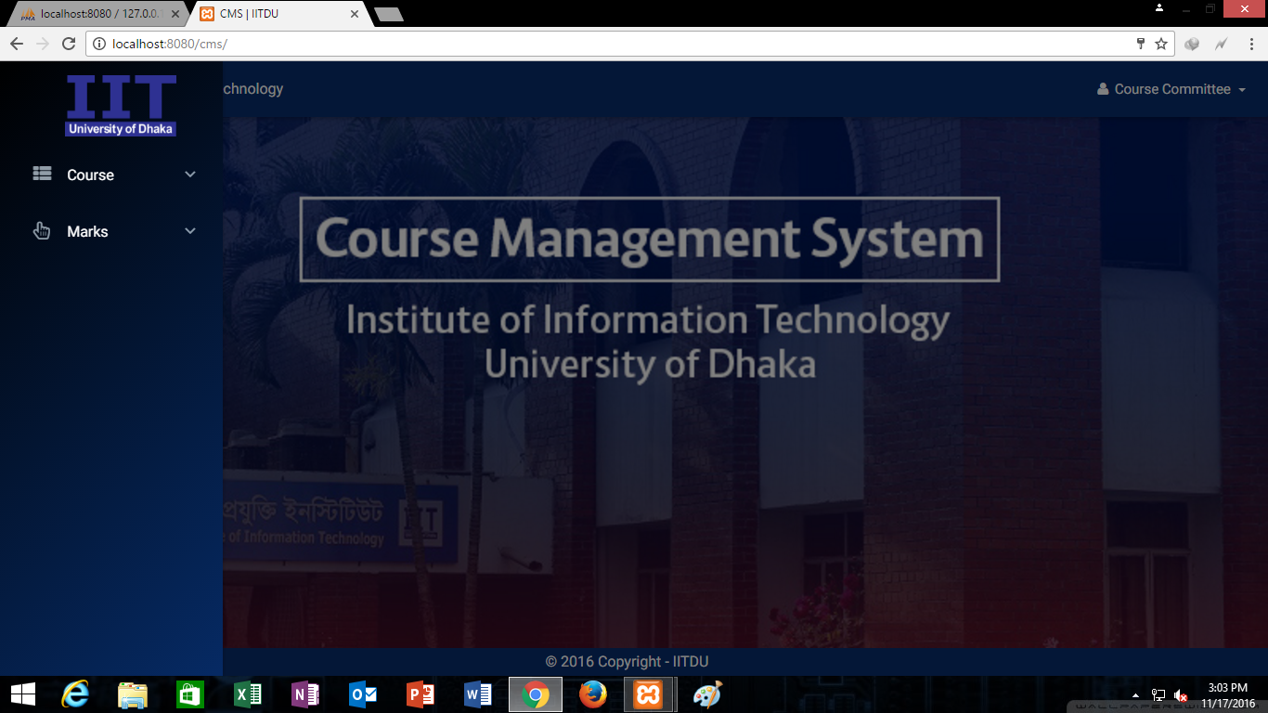

In course committee home page, there are two options for the committee. They are, course list page and marks deadline page.

Course Committee (Course list page):

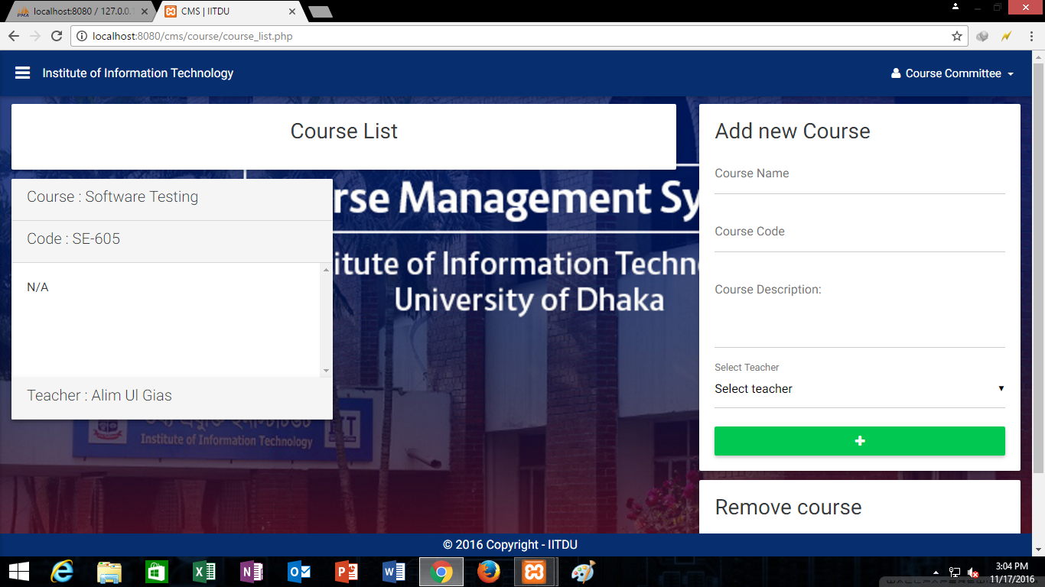

In course list page the committee can add a new course with a specified teacher. Committee can also remove course.

Course Committee (Marks deadline page):

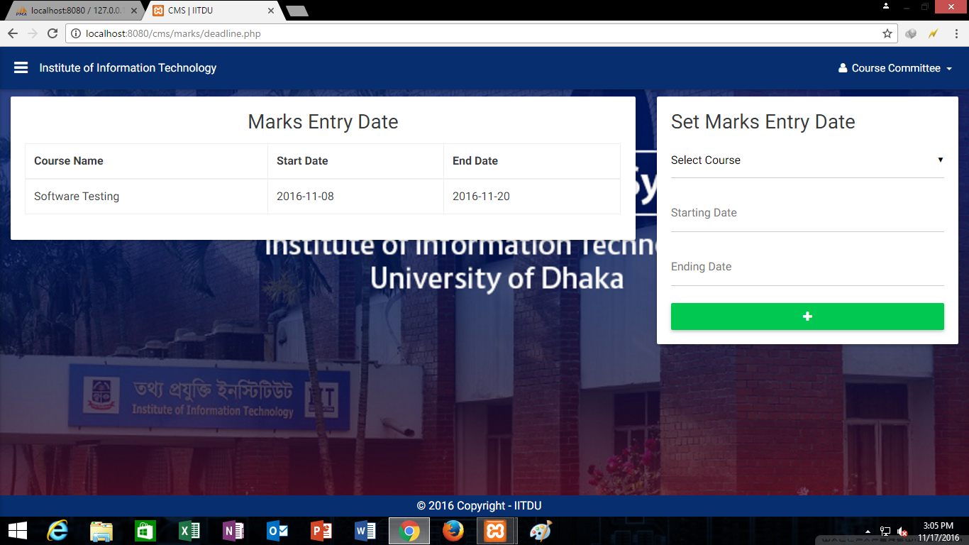

Set a deadline for a particular course.

Teacher (Home page):

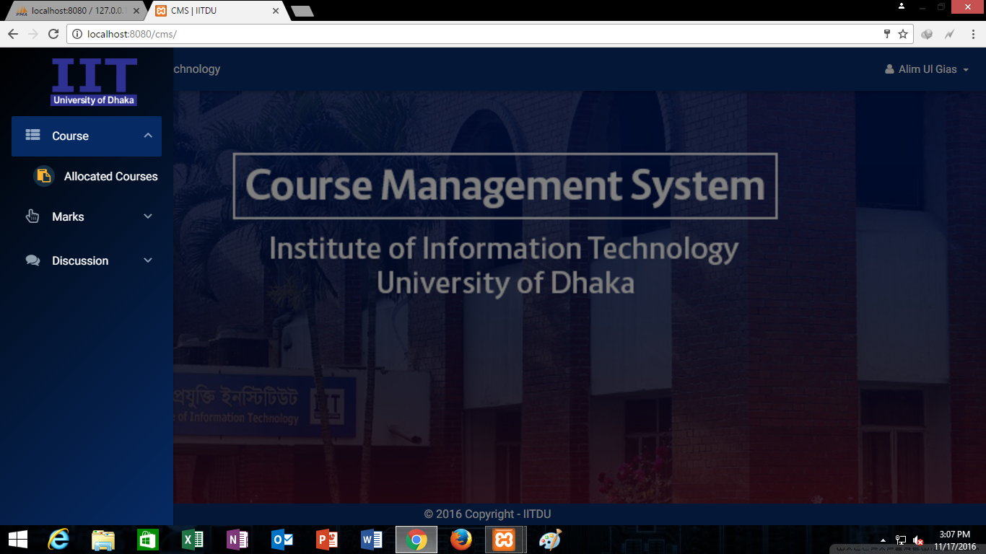

In home page teachers, can see the allocated courses, enter marks, and discussions.

Teacher (Allocated courses page):

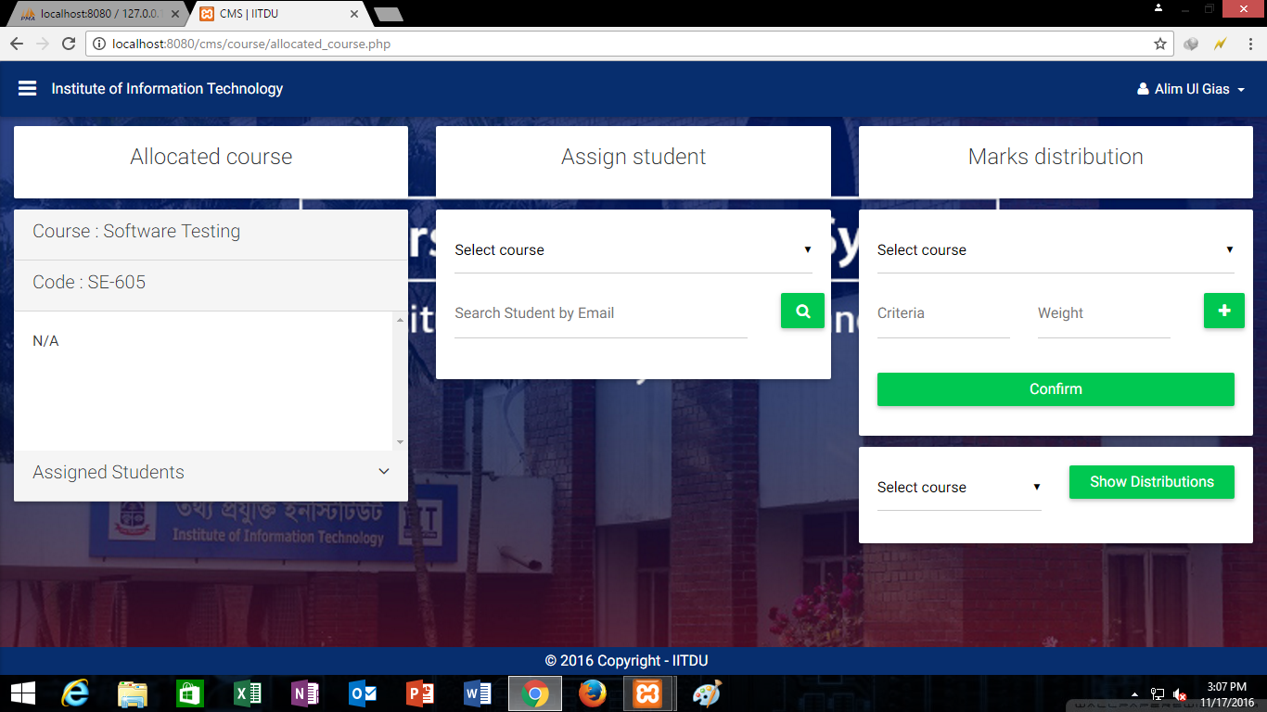

Can assign student in particular course and can generate the marks distribution.

Teacher (Enter marks page):

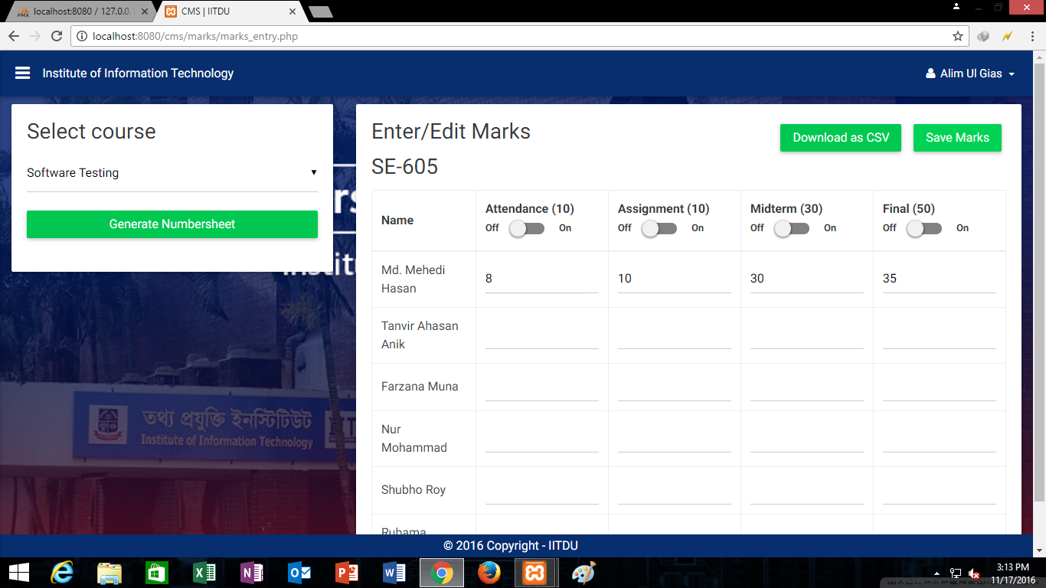

Teacher can enter marks in various fields and restrict the viewability

Teacher (Discussion page):

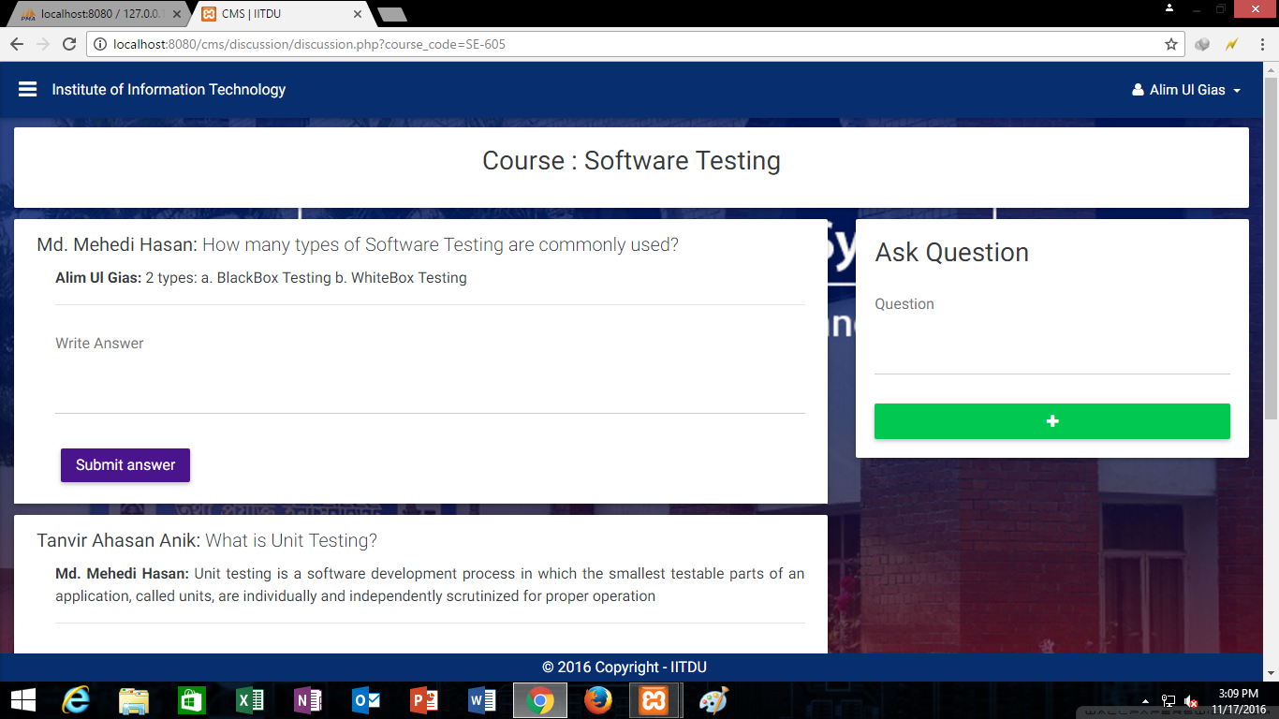

Can discuss course materials.

Student (Home page):

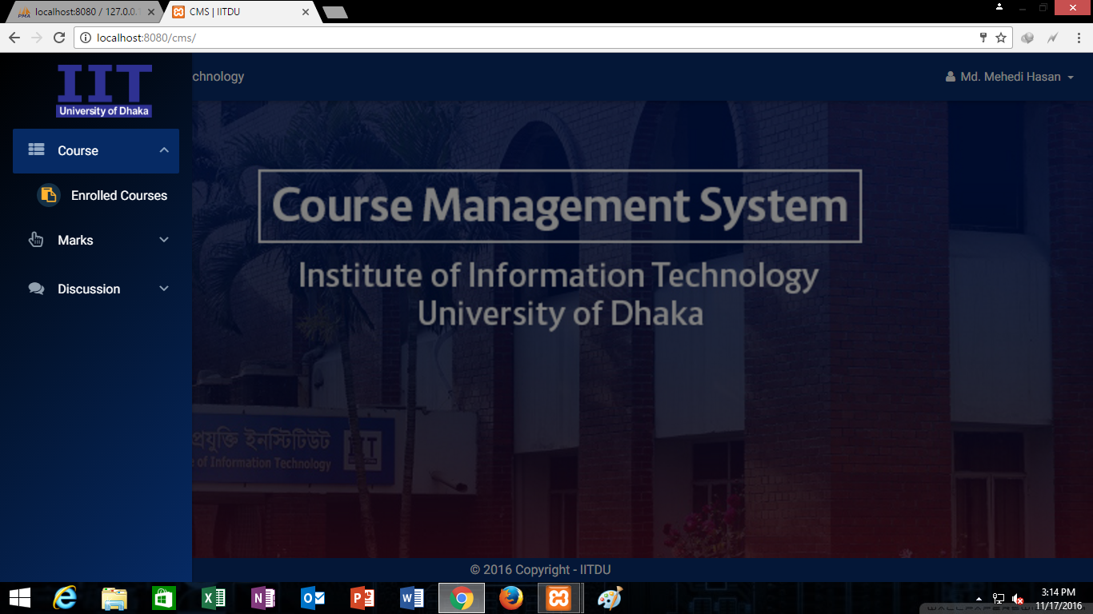

Student (Enrolled courses page):

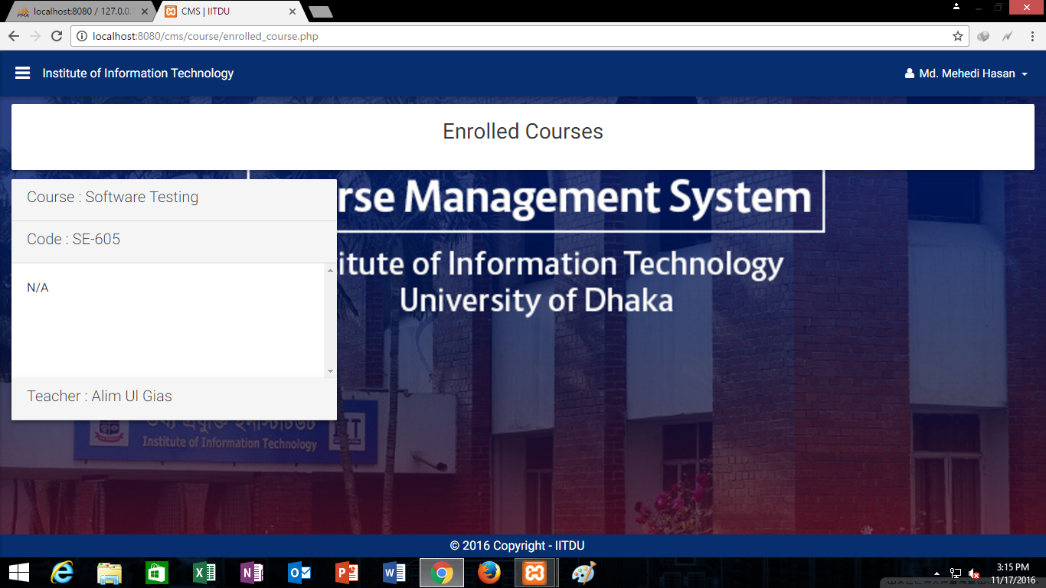

Student can check out his/her enrolled courses

Student (View marks page):

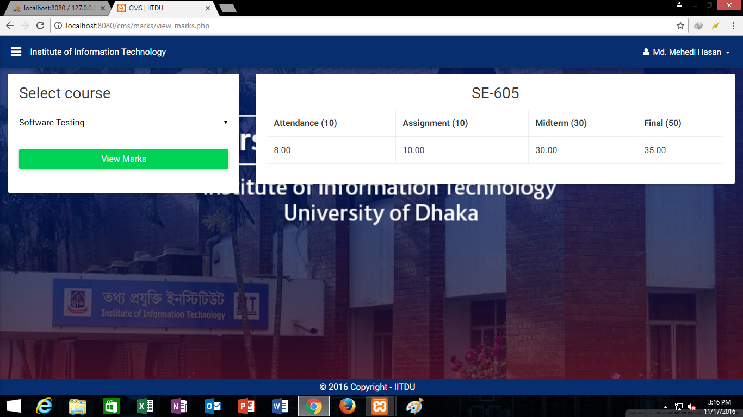

Student can view marks if it is viewable.

Student (Account information page):

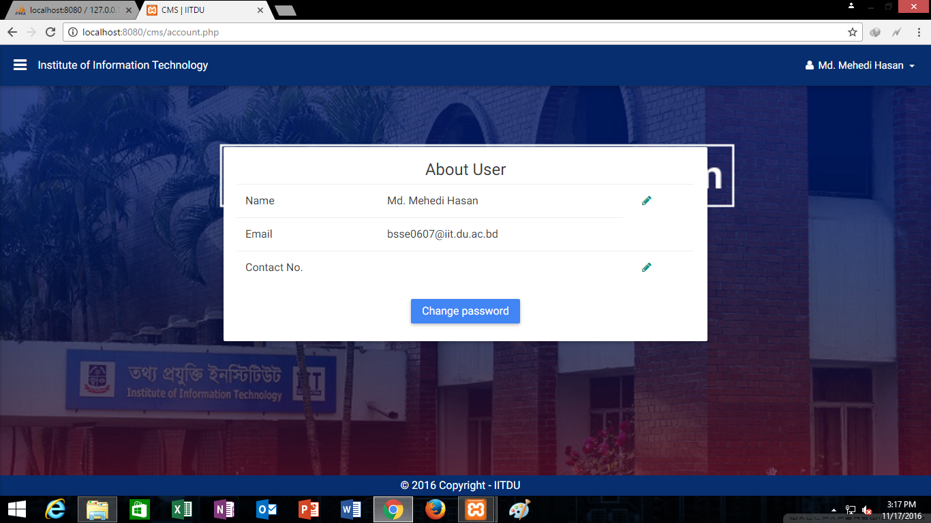

User can see his/ her account details.

